Lines Activity

Purpose:
* review using classes
* review using methods
* practice using methods with parameters
* practice using methods with return values

Task:

Part 1
Write a class Line.java to calculate the different property of a line.
The class should include the following methods

- length – takes the coordinates of a line segment as input and returns its length
public static double length (int x1, int y1, int x2, int y2)

- slope – takes the coordinates of a line segment as input and returns its slope
public static double slope (int x1, int y1, int x2, int y2)

Hint:
The formula for calculating length of a line is 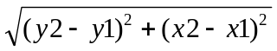
The formula for calculating slope of a line is 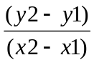
Use Math.sqrt(num) to find the square root of a number

Part 2
Write a class CheckLine.java with the main methods which asks users for coordinates of two line, then uses the methods in Line.java to check if the lines have the same length, and if the lines are parallel or perpendicular.

Here is a sample run:

Please enter the two coordinates of line 1:
Vertex 1 x-value: 0
Vertex 1 y-value: 0

Vertex 2 x-value: 1
Vertex 2 y-value: 1

Please enter the two coordinates of line 2:
Vertex 1 x-value: 2
Vertex 1 y-value: 2

Vertex 2 x-value: 4
Vertex 2 y-value: 4

Results:
The two lines do not have the same length.
The two lines are parallel.

